Exp No : 11
STUDY OF GPIO & BIT ADDRESSING IN AT89C51
AIM :
To study GPIO control and bit-addressable SFR using Embedded C.
SOFTWARE REQUIRED :
- Keil
PROGRAM :
#include <reg51.h>
sbit LED1 = P1^0;
sbit LED2 = P1^1;
void delay()
{
unsigned int i,j;
for(i=0;i<200;i++)
for(j=0;j<1000;j++);
}
void main()
{
while(1)
{
LED1 = 1;
LED2 = 0;
delay();
LED1 = 0;
LED2 = 1;
delay();
}
}

OUTPUT :
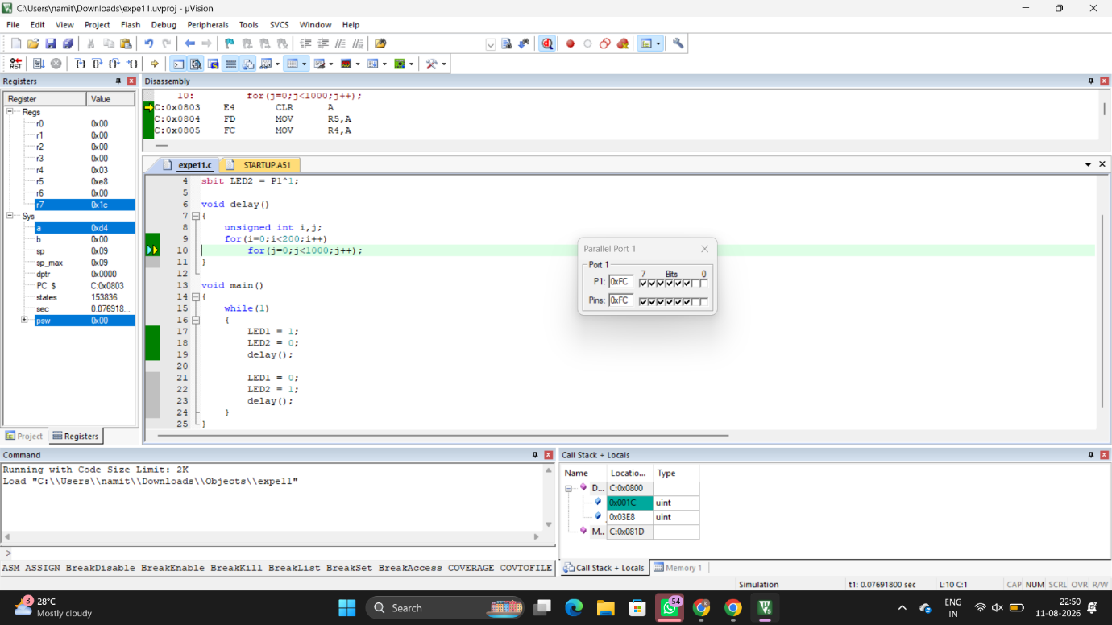

RESULT :
Thus GPIO and bit addressing was studied and in Port1 the pins P1.0 and P1.1 toggled alternately.

